**Project Prospectus**

Title: Measuring Maternal Wellbeing Accessibility in Minnesota

Notice: Dr. Bryan Runck

Author: Lauren Roach

Date: September 27, 2022

**Project Repository:**<https://github.com/L-roach/GIS5571/tree/main/Final%20Project>

**Google Drive Link:** N/A

**Time Spent:** Five hours

**Abstract**

This project will explore the capacity of an area within the state of Minnesota to provide access to resources needed for maternal wellbeing. By sourcing point data from Google Places, maps will be created that depict the locations of these various resources (listed in Table 1). Using a tessellation grid and weighted sums of the cells, the accessibility of resources will be analyzed. Ultimately, the project will culminate in a Maternal Wellbeing Index, depicted at the census tract and county level via choropleth maps. I expect the urban areas to have a high score (high access to resources) and rural areas, particularly those in northern and western Minnesota, to have a low score (low access to resources).

**Problem Statement**

The prenatal and post-partum periods are very significant moments for maternal health. Access to resources can shape the trajectory of a pregnancy and specifically affect the health of both the mother and baby. For this reason, understanding access—or lack thereof—to resources like dental care, groceries, and fitness opportunities for prenatal and post-partum women is crucial for public health practitioners. Where disease mapping measures the burden of a disease over a particular area and population, this method of accessibility mapping measures the access to resources needed during a vulnerable state of health for women in the state of Minnesota.

*Table 1. Data Needed*

|  |  |  |  |  |  |  |
| --- | --- | --- | --- | --- | --- | --- |
| **#** | **Requirement** | **Defined As** | **(Spatial) Data** | **Attribute Data** | **Dataset** | **Preparation** |
| 1 | MN Shapefile | State of MN shapefile | Polygon | Shapefile | MN Geospatial Commons | N/A |
| 2 | Location data | Locations of resources needed during pregnancy and post-partum periods | Point | Type of resource | Google Places | Extraction |
| 3 | Tessellation grid | Hexagonal cells | Polygon | N/A | ArcGIS Tool | Create |

**Input Data**

The data used in this project will be point data sourced from Google Places. The data identifies the location of various resources throughout the state of Minnesota, the geographical area of the analysis.

Figure 1 Resources Needed during Pregnancy and Post-partum Periods

*Table 2. Resources Data*

|  |  |  |  |  |
| --- | --- | --- | --- | --- |
| **#** | **Title** | **Purpose in Analysis** | **Link to Source** | **Group** |
| 1 | Dentist offices | Raw input data for point location | Google Places | Group 1 |
| 2 | Mental health providers | Raw input data for point location | Google Places | Group 1 |
| 3 | Grocery stores | Raw input data for point location | Google Places | Group 2 |
| 4 | WIC locations | Raw input data for point location | Google Places | Group 2 |
| 5 | OBGYN Offices | Raw input data for point location | Google Places | Group 1 |
| 6 | Playgrounds | Raw input data for feature | Google Places | Group 3 |
| 7 | Fitness centers | Raw input data for point location | Google Places | Group 3 |
| 8 | Farmers markets | Raw input data for point location | Google Places | Group 2 |
| 9 | Food shelves | Raw input data for point location | Google Places | Group 2 |
| 10 | Pelvic Occupational Therapist/ Physical Therapist | Raw input data for point location | Google Places | Group 5 |
| 11 | Libraries | Raw input data for point location | Google Places | Group 4 |
| 12 | Midwifery clinics | Raw input data for point location | Google Places | Group 1 |

**Methods**

* Download and add MN shapefile
* Find points of resource locations through Google Places and add data to map
* Generate tessellation grid of 10-mile hexagonal cells
* Select by location for tessellation grid within MN
* Count the number of points in each grid using summarize within (add point count to each polygon) for each group; creating a new field which stores the count in each cell
* Group 1 is weighted more (50%) than other resources and this weighting calculation would be calculated in a new field
* Use weighted sum to find sum of scores of each cell
* Overlay county and census tract shapefiles
* Summarize cells with points within each shapefile and aggregate to an index score
* Create one map that displays the cells with points, and the immediate neighboring cells
* Create one map that shows the cells without points or their immediate neighbors
* Create one choropleth map that shows the index score for each census tract
* Create one choropleth map that show the index score for each county
* Perform sensitivity analysis with the counts of the tessellation cells

**Results**

There will be four maps produced for this project and report. These maps will display the location of resources via the tessellation cells throughout Minnesota, the location of areas without resources, the index scores for the census tracts, and the index scores for the counties. I expect the urban areas to have a higher score and rural areas to have a lower score.

Figure Point Locations of Resources

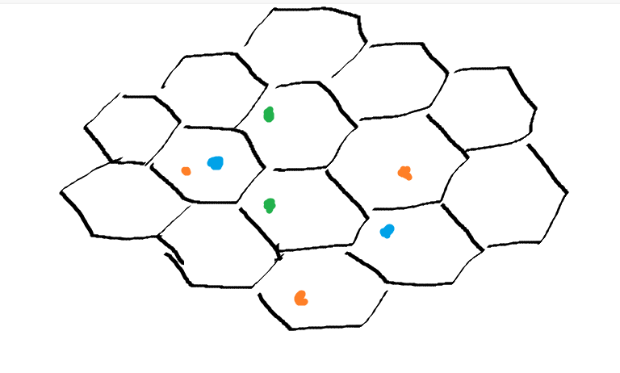

Figure Tessellation Grid with Points

Figure Example Choropleth Map from Minnesota Department of Health

**Results Verification**

To verify the results, I will perform a sensitivity analysis. This involves iteratively changing the value of cells by 5% to examine the difference in outputs from the original input and the test input.

**Discussion and Conclusion**

Since I expect the scores to vary based on urban/rural classification, I assume the resources will be more centralized around urban centers. Additionally, I think resources will be less available in more disadvantaged communities and near or on tribal lands.

**References**

None to list at this time.

**Self-score**

|  |  |  |  |
| --- | --- | --- | --- |
| **Category** | **Description** | **Points Possible** | **Score** |
| **Structural Elements** | All elements of a lab report are included **(2 points each)**:  Title, Notice: Dr. Bryan Runck, Author, Project Repository, Date, Abstract, Problem Statement, Input Data w/ tables, Methods w/ Data, Flow Diagrams, Results, Results Verification, Discussion and Conclusion, References in common format, Self-score | 28 | **N/A** |
| **Clarity of Content** | Each element above is executed at a professional level so that someone can understand the goal, data, methods, results, and their validity and implications in a 5 minute reading at a cursory-level, and in a 30 minute meeting at a deep level **(12 points)**. There is a clear connection from data to results to discussion and conclusion **(12 points)**. | 24 | **N/A** |
| **Reproducibility** | Results are completely reproducible by someone with basic GIS training. There is no ambiguity in data flow or rationale for data operations. Every step is documented and justified. | 28 | **N/A** |
| **Verification** | Results are correct in that they have been verified in comparison to some standard. The standard is clearly stated **(10 points)**, the method of comparison is clearly stated **(5 points)**, and the result of verification is clearly stated **(5 points)**. | 20 | **N/A** |
|  |  | 100 | **N/A** |